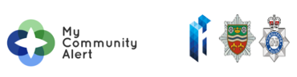

Effective communication is an essential and pivotal cornerstone of modern-day policing.
My Community Alert is a free messaging system operated by Humberside Police, Humberside Fire & Rescue Service, and Humberside Office of the Police & Crime Commissioner, giving you live information about incidents happening in your area.
Choose how you receive messages, by either phone or email, how often you want to hear from us and about the issues that matter to you.
When something happens that you’ve told us you want to hear about, your local officer will send you the details, whether that’s notice of a road closure due to a collision or a burglar who has been caught in a nearby garden.
Subscribe to My Community Alert to be the first to know about issues that might affect you or your family.
